Title

The Analysis of the Presentation and Collection of Data of Weather.ph

I. Project Authors

**Project Consultant**

|  |  |  |
| --- | --- | --- |
| **Name** | **Position** | **Email** |
| Mr. Ernesto Boydon | Professor | ernestob@apc.edu.ph |

**Project Adviser**

|  |  |  |
| --- | --- | --- |
| **Name** | **Position** | **Email** |
| Mr. Paulo Oblepias | Professor | pauloo@apc.edu.ph |

**Project Team**

|  |  |  |
| --- | --- | --- |
| **Name** | **Position** | **Email** |
| Miguel Jaime S. Mayor | Project Manager | msmayor@student.apc.edu.ph |
| Adrian Tobias | Project Researcher | adtobias@student.apc.edu.ph |
| Joanna De Guzman | Project Editor | jddeguzman@student.apc.edu.ph |

II. Introduction

Nowadays, presentation of data and its collection is being researched and studied by many people in the IT profession. Databases, techniques of capturing the data, and presenting it orderly is one of goals of that study. This study focuses on the presentation and the collection of the data in the company called Weather.ph. What is Weather.ph? Weather.ph is a company under Aboitiz Equity, and its primary goal is to make all the people in the nation aware about the weather in the different regions of the Philippines. They handle the installation and operation of the weather machines. They have a problem existing in their system which is presentation of data this study makes use of its gathered information and data to focus on exploring that problem.

**2.1 Background of the Problem**

Keeping data consistent is hard. Especially in the Operation and Maintenance Department since they still use excel as of this day to keep their data constant. They record each data from the data logger and put it on excel, then the excel file is passed around the people in the department to ensure that data and information is constant. But the problem is that there is a chance that the data could be overwritten by previous files; new data could be loss for this reason. Work would be delayed and operations will be push back until the data is consistent again.

**2.2 Statement of the Problem**

How do we improve the file system for the weather machine information to become consistent and more reliable than the old system? According to Mr. Alvin Tobias’ statement, the Operations and Maintenance department aims to make data presentation and information gathering quicker than the old system, which is Excel. The work which the Operations and Maintenance department is doing is gathering of data and making sure that weather stations are operational and ready to record data. The department still uses excel as the means of recording data and information from weather stations. They need to keep on passing the excel file just to keep everything updated. With this way, confusion increases in the department and may delay work just because of a simple file organization problem. Managers must keep everything working and disruption of the work flow must not occur. Sometimes, files get overwritten with previous versions of the file and result to data loss. In response to this problem, our study proposes to analyze the possible ways of presenting and collecting the data through various ways. With this study, we will use this as a basis for making a program for our later subjects which makes data presentation quicker and will eliminate the need of need to pass on the file just to keep everyone in the department updated.

**2.3 Objectives**

The researchers of the study have decided that the following are the main specific objectives of the study:

- To improve the file system to a better and faster file system which its speed is 50% faster than the old file system

- To come up with a proposal of usable methods that can lead into create a program that will solve the problem of Weather.ph completely

- To gather all information and data from such sources like the interviewees, terms and definitions of problem, and related article which contributes in finalizing the best method for the problem.

**2.4 Significance**

The result of this analysis on how to present data and how to collect it will result in a method which will solve the problem that the Weather.ph is now facing. This method when applied to the program that is going to be built in the later subjects, would significantly improve the ease of handling data and information within the company. Specifically, the system will be greatly beneficial to the operations department of the company in handling the equipment used for the company and bring ease to the input and output of data and information. The system will not only bring ease to the collection and manipulation of data, but also increase the reliability against the loss or errors that could occur to the information they require. The system will also greatly benefit the maintenance personnel due to the fact that they could easily determine the exact quantity of the equipment, the quality, and the availability.

**2.5 Scope and Limitations**

The departments that will be using this system are the operations & the maintenance department and the IT department. The study will not cover other departments such as financial department, Human resources, etc. This system is limited to the operations & maintenance departments and IT Department only. This study is also limited to the analysis of the presentation and collection of data in the Operations and Maintenance department of the company; it does not focus in other problems in the company.

**2.6 Data used to describe Weather Station**

Station – Weather Station Number; Example 000001  
Name – Name of the Weather Station, usually the location or place of the weather station is the name; For example SM North  
Sponsor – Name of the Sponsor; Example APC holdings  
Province – Name of the province where weather station is placed; For example Paranaque  
Region – Region of the weather machine; For example NCR or National Capital Region  
Logger – Name of the logger used for the weather machine; For example GIZMO  
Sensor – Name of the sensor used, usually the company who manufactures it. For example ACE  
PhoneNumber – The phone number which the weather station uses to transmit data; Ex. 09090909090  
Payment – Type of payment for the phone number, either PREPAID or POSTPAID  
Telco – The network which the phone number is subscribe to; SMART, GLOBE, SUN etc  
Gateway – Name of the gateway for the weather machine  
Solar – Solar panelled or not  
Last Session – Last session of transmission of data; Date for example 2015-12-31_11:32  
Signal – Signal strength of the weather station; for example 25  
Timeout – Connection failure; Either no or black, no referring to no connection  
Updated – Last date of update; Date for example 2015-11-23_9:30  
Journal – Comments about the weather station

III. Diagrams

**3.1 Context Diagram**

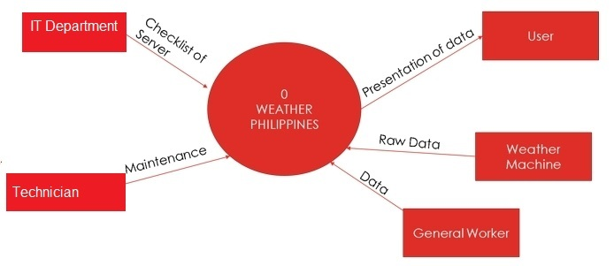

**3.2 Diagram 0**

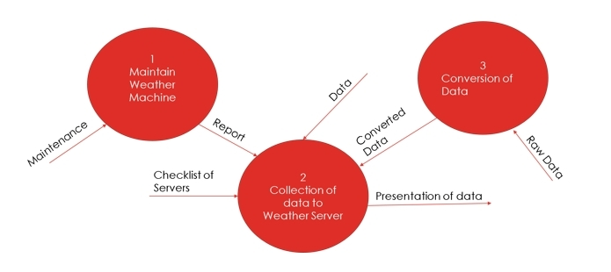

**3.3 Diagram 1**

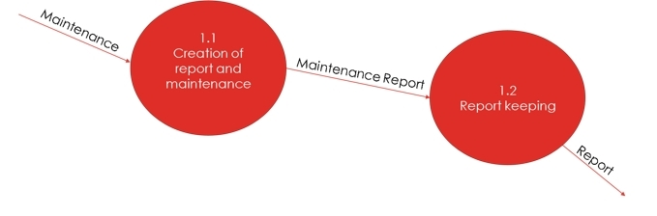

**3.4 Diagram 2**

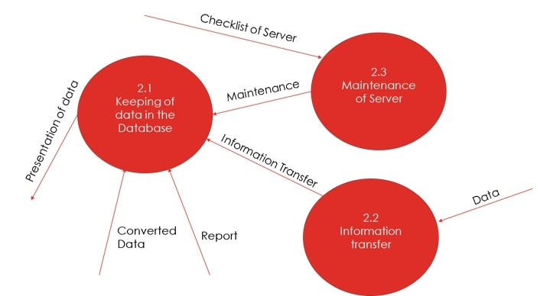

**3.5 Tree Diagram**

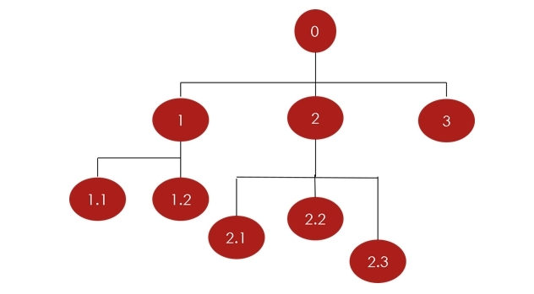

0 – Weather Philippines Diagram

Diagram 0  
1 – Maintain Weather Machine  
2 – Collection of data to Weather Server  
3 – Conversion of Data

Diagram 1  
1.1 – Creation of report and maintenance  
1.2 – Report keeping  
Diagram 2  
2.1 – Keeping of data in the Database  
2.2 – Information transfer  
2.3 – Maintenance of Server

Process Specification

PROCESS SPECIFICATION OF DIAGRAM 0 PRECONDITION OF Process 3 – Conversion of Data

* DATA_UP is matched with DATA_DB specs

POSTCONDITION

* DATA_UP or Converted Data is uploaded to the server

PROCESS SPECIFICATION OF DIAGRAM 1  
  
PRECONDITION OF Process 1.1 – Creation of report and maintenance

* REPORT FORM contains all data needed

POSTCONDITION

* No error from comparison of data of REPORT FORM

PRECONDITION OF Process 1.2 – Report keeping

* REPORT FORM has no null values and all fields are complete

POSTCONDITION

* REPORT FORM + TIMESTAMP to DATABASE

PROCESS SPECIFICATION OF DIAGRAM 2  
  
PRECONDITION OF Process 2.1 – Keeping of data in the Database

* INFO from Process 2.2 and is complete

POSTCONDITION

* New entry for data with current timestamp and then upload to Database

PRECONDITION OF Process 2.2 – Information transfer

* DATA from General Worker is captured

POSTCONDITION

* DATA is uploaded

PRECONDITION OF Process 2.3 – Maintenance of Server

* Checklist of server is checked and complete

POSTCONDITION

* Maintenance is applied to server